**Login Page**

1. Sign in

A user can sign in successfully by entering correct email and password.

A user can choose the identity as a user or an organizer.

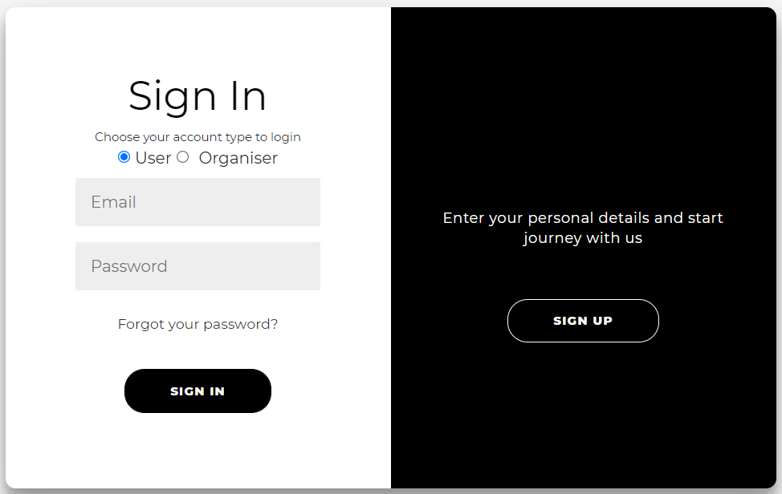

1. Verification code

After entered the email and password, a user still need to enter a verification code to access the system.

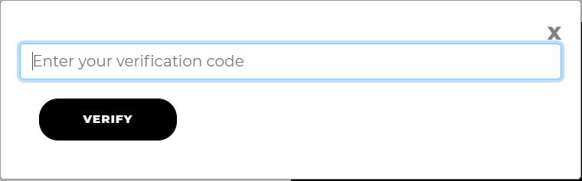

1. Verification email

A user can receive an verification email successfully.

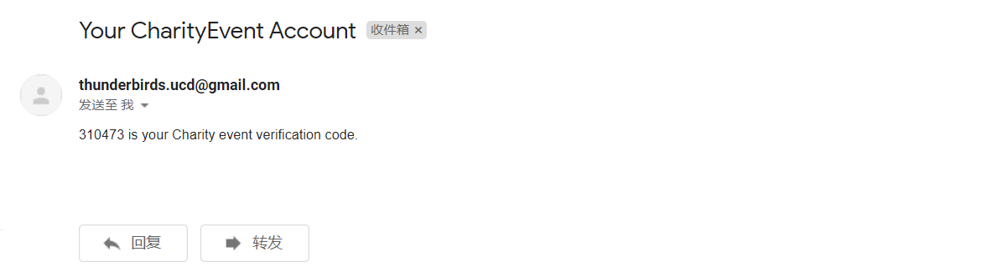

**Sign up Page**

1. Create account

A user can sign up successfully by entering appropriate information.

A user can choose the identity as a user or an organizer.

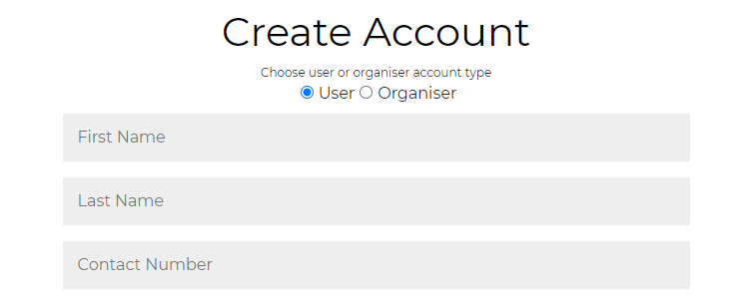

1. Age limit

When user is under 18 years old, he/she couldn’t sign up an account.

Suggestion: change the sign to “You can only sign up an account when you over 18”.

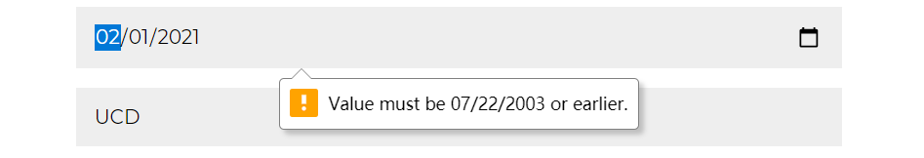

1. Email format matching

Appropriate Email format checking.

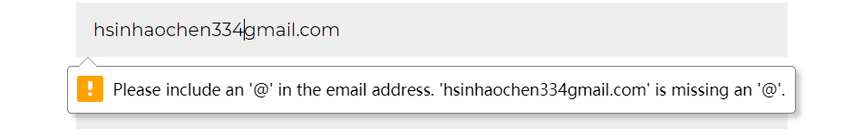

1. Moblie number format matching

Appropriate Moblie number format checking.

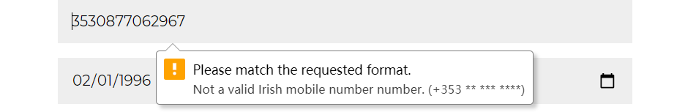

1. Password format matching

Appropriate Password format checking.

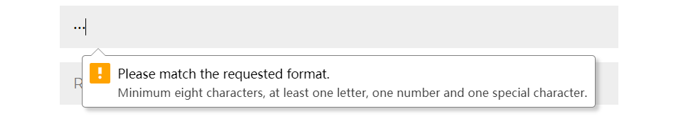

1. Password do not match

When user entered different passwords by twice, the system would show the message.

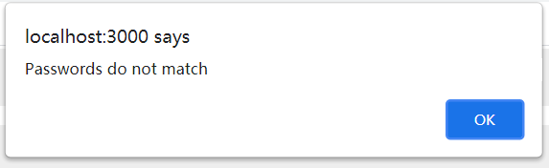

1. Repeat sign up

Appropriate checking when the email or phone number has already registered.

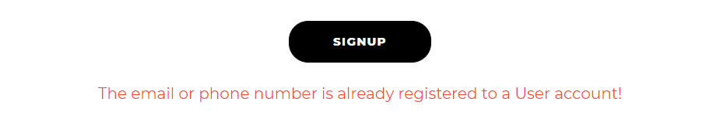

**About us Page**

1. Team information

A user can see our team information by click ‘About Us’ button.

A user can easily access each member’s facebook, twitter, linkedin, Instagram by clicking buttons.

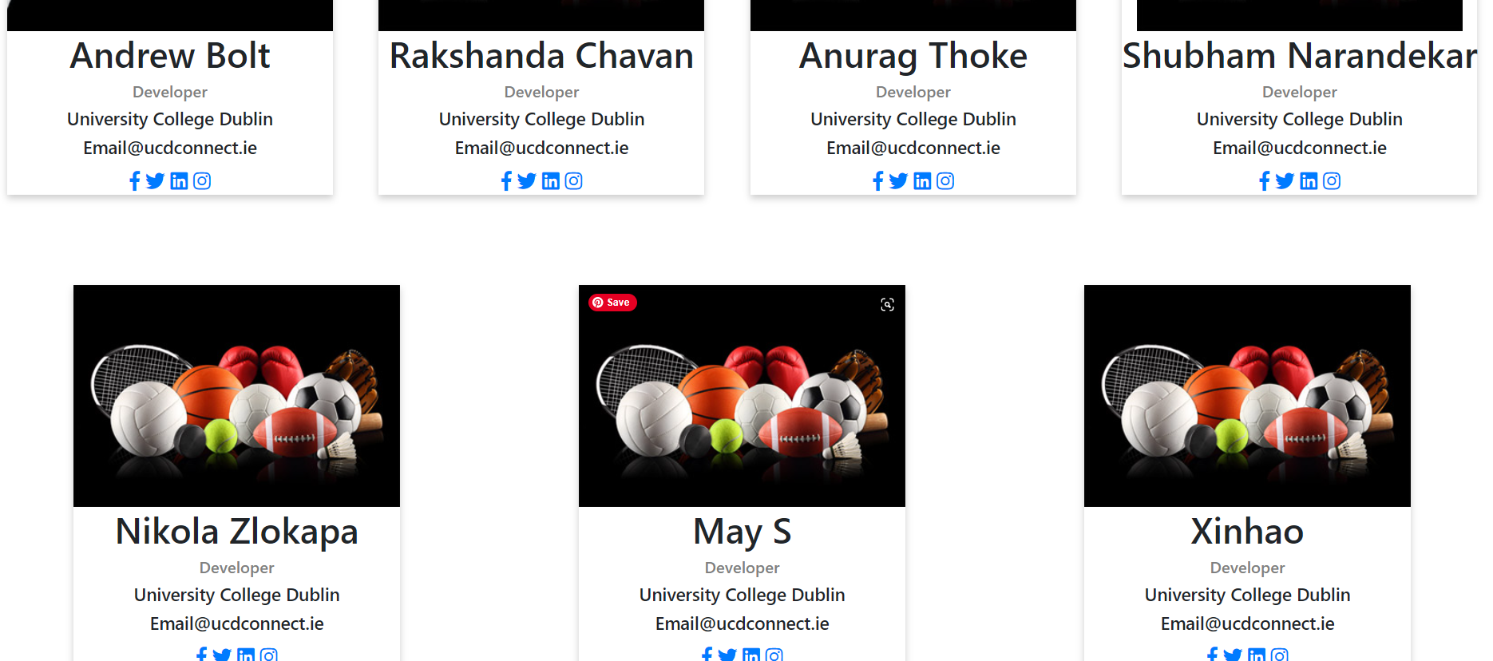

**Home Page**

1. Recommended activity

A user can see recommended activities in important locations and switch activities by clicking the buttons.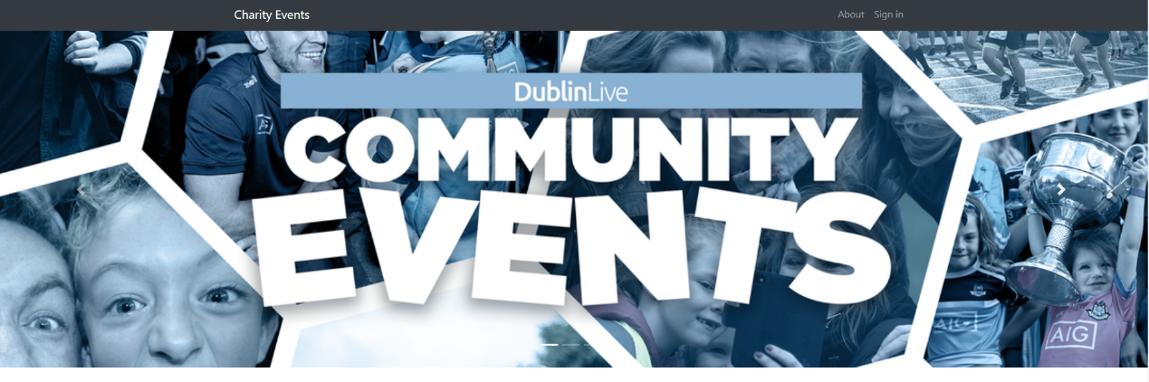

1. Page layout

A user can see the activities which are arranged on the page in the correct classification and good layout.

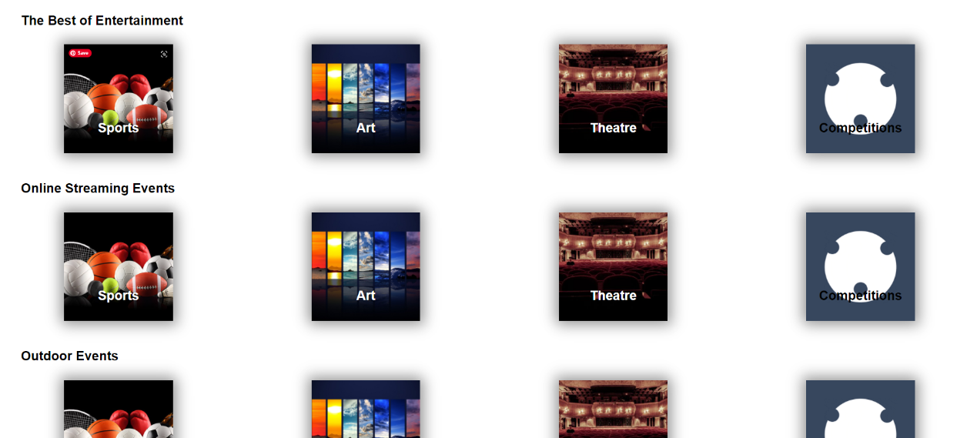

1. Event searching

A user can search a specific event by entering key word on search bar.

